Optimizing Value of Emergency Department Care: Impact of Physician Feedback using a Composite Quality and Resource Use Metric

Principal Investigator: Shabnam Jain, MD^{1,2}
Collaborator: Gary Frank, MD¹

¹Children’s Healthcare of Atlanta,
²Emory University School of Medicine
Atlanta GA.

Project Summary:

Children’s Healthcare of Atlanta represents one of the largest pediatric emergency department systems in the nation with over 170,000 annual visits provided at its three campuses. While there have been major strides in improving efficiency in the emergency departments (ED) at Children’s, gaps in quality remain, particularly with respect to variation in care delivery within and across the campuses. We recently demonstrated up to an eight-fold variation in resource use in the ED at the individual provider level that persisted after adjusting for severity and case-mix. Further, excess resource use negatively impacted efficiency of ED care without improving outcomes. Other investigators have also demonstrated wide variations in health service delivery and spending that do not correlate with quality; excessive variation in resource utilization with no demonstrable impact on outcomes can be used as a surrogate marker of wasteful medical care. Finally, ED care is perceived as being expensive, sometimes due to excessive diagnostic testing and interventions. While many factors contribute to this, we have chosen to focus on excessive variation in resource utilization. As part of a system-wide quality improvement (QI) initiative, we have developed a comprehensive ED physician performance scorecard based on severity adjusted measures of resource use, efficiency, and outcomes for four common ED conditions.

The specific aims of this proposal are: (1) to develop a composite measure that combines multiple measures of physician performance to identify high-value ED care using a single metric, and (2) to evaluate the impact of physician feedback via a balanced and comprehensive performance scorecard on ED resource use, quality and efficiency. Using a cross-sectional study design, we will perform descriptive and exploratory statistics using practice data of 80 physicians at 2 pediatric EDs to compute a composite metric of performance. After 12 months of quarterly feedback, we will perform trend analysis to evaluate impact of the QI intervention on ED physician practice, both in terms of degree of variation as well as reduction in resource use.

We propose to develop a prototype composite measure for ED physician performance that uses routinely collected feasible metrics and can be easily adapted to any pediatric or adult ED. Using this composite measure of quality system-wide at Children’s, we hope to identify ED physicians who provide high-value care (higher quality with lower resource use). We hope that this model can eventually be expanded to address unexplained variation in other areas outside the ED. Successful implementation of QI projects with a direct impact on patient care is an important step in optimizing the value of healthcare delivery, an important agenda in the healthcare reform.

INTRODUCTION

Children’s Healthcare of Atlanta represents one of the largest and most comprehensive pediatric emergency department (ED) systems in the country with over 170,000 patient visits annually. The system serves over 80% of the metropolitan Atlanta pediatric population. Emergency care is provided by nearly 80 providers at three separate campuses; the bulk of pediatric hospital admissions occur via the EDs. Recent efforts to improve quality have focused on service provided to patients and have resulted in significant strides in improved efficiency in the EDs; however, gaps in quality persist with respect to clinical care within and across campuses.

We recently demonstrated significant variation in resource use in the ED at the individual provider level that persisted after adjusting for severity and case-mix.¹ Hospital admission rates varied up to 8-fold and head computerized tomography utilization varied up to 5-fold (Table 1). Furthermore, higher resource utilization was associated with increased ED length of stay, but did not improve quality of care measured as return visits to the ED.

Table 1: Case-mix Adjusted Resource Utilization by Physicians Practicing in Two Children’s Healthcare of Atlanta Pediatric Emergency Departments (2003-2006)
 | ED1 (n=36) | ED2 (n=45)
All Visits:
Patients seen/Physician, mean, median (range) | 4546, 4769  (1042-9296) | 6426, 5661  (1008-17620)
Admissions(%), mean, median  (range) | 13.3, 13.8  (6.3-18.0) | 12.1, 13.2  (2.5-19.4)
For Patients sent home:
Labs (%), mean, median  (range) | 20.7, 20.6  (18.3-23.9) | 22.3, 22.2  (17.6-26.2)
Imaging (%), mean, median  (range) | 14.4, 14.3  (10.3-16.4) | 15.4, 15.8 (10.9-20.6)
Head CT scan (%), mean, median (range) | 1.9, 2.0  (1.1-2.5) | 2.9, 3.3  (0.9-4.8)
IV Therapy (%), mean, median  (range) | 7.1, 6.9  (4.9-10.4) | 7.2, 7.5  (3.6-11.4)

Preliminary Data:

In a subsequent study, we performed follow-up data analysis of Children’s ED physicians’ practice in mid-acuity patients with four common conditions (fever, gastroenteritis, head injury and abdominal pain) during 2008-09. Once again we found clinically significant variation in resource use for all conditions with no increase in return rates for providers with decreased resource use. Figure 1 shows our data for patients with head injury – head CT use for mid-acuity patients with head injury varied from 4-54%, with little correlation between CT use and return rates.

Figure 1: Head CT use (%) and Return Rate (%) in Mid-acuity Patients with Head Injury seen by Physicians Practicing in Two Children’s Healthcare of Atlanta Pediatric Emergency Departments (2008-2009)

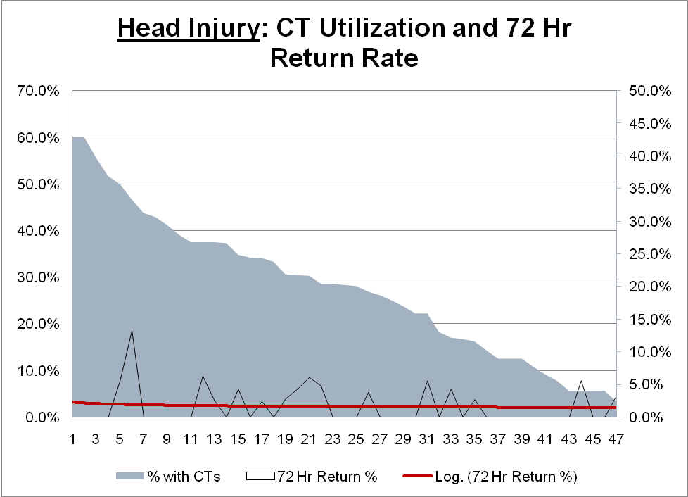
Range: 4-54%

Other investigators have also demonstrated wide variations in health service delivery and spending that do not correlate with quality; excessive variation in resource utilization with no demonstrable impact on outcomes can be used as a surrogate marker of wasteful medical care.²⁻⁷ Wide variations in practice have been noted in many fields of pediatrics, including emergency medicine.⁸⁻²⁰ Emergency Department (ED) care is expensive and carries a perception of excessive diagnostic testing and therapies especially for the non-emergent conditions that often comprise a large share of the case mix in the typical ED. In the ED, excessive interventions can increase costs and exacerbate the problem of ED crowding and long wait times. EDs also account for over 50% of hospital admissions. As such, ED providers influence costly and sometimes discretionary decisions, some of which, such as a hospital admission, can have major downstream effects.

While several factors contribute to the current state in emergency care, we have chosen to focus on reducing the wide variation in resource use amongst individual providers that cannot be explained by patient severity or presenting complaint. However, there are significant challenges to changing practice, including inertia, malpractice concerns, reimbursement incentives, and patient demand.²¹ Efforts to standardize practice using evidence based guidelines have been ongoing, but significant degrees of variation in practice remain. Physician performance profiling is beginning to be used to improve provider performance.²⁴⁻²⁶ Studies have shown that when physicians are provided with data on how their practice compares with their peer group, they are usually amenable to discussing practice changes, especially when appropriate practice guidelines are made available to them.²⁷ Previous publications on provider profiling for cost and quality management in the ED have underscored the importance of adjusting for acuity, diagnosis, and patient outcomes.²⁷ Furthermore, it has been recommended that comparisons be made by relating the utilization/outcome rate for an individual physician with a norm that is based on peer practice, external standards or acceptable practice guidelines.²⁷ Despite these recommendations, lack of a reliable and broadly accepted mechanism for measuring variability and disseminating such information has made it difficult to change physician practice.

As part of a system-wide quality improvement (QI) initiative, we have developed a physician performance scorecard for the ED physicians which incorporates most of the current recommendations for ED physician profiling and feedback. The scorecard we have developed uses severity adjustment based on condition and acuity, and includes data on resource use, length of stay as efficiency metric, and return rates as a surrogate for ED quality. The individual physician’s performance is shown in relation to his/her peers’ practice (see Appendix for sample scorecard).

Justification for Study: While our existing report card is comprehensive and provides ED physicians with multiple dimensions of their performance, it stops short of providing a single meaningful metric of overall performance. In order to optimize value (quality per unit of cost), we need to identify physicians who deliver high quality, lower-cost care; this requires a metric that can account for both quality and resource use. The National Quality Forum has recently emphasized the urgent need to develop composite measures that account for quality, efficiency and costs to help physicians adopt high-value practice styles.²⁸ In addition, there are limited studies evaluating the impact of performance scorecards in ED settings; we are not aware of any studies that have evaluated the impact of providing ED physicians data on both quality and resource use. Finally, we hope that this model can eventually be developed to address unexplained variation in other areas outside the ED. While the direct benefit of such efforts is improved physician performance, the ultimate goal of reducing resource use while maintaining/improving outcomes is to optimize value in healthcare delivery. This impacts not just patients, but the healthcare system as a whole.

Aims: (1) To develop a composite measure that combines multiple measures of physician performance to identify high-value ED care using a single metric.
(2) To evaluate the impact of physician feedback via a balanced and comprehensive physician performance scorecard on ED resource use, quality and efficiency.

Study locations: The study will be conducted at a system-wide level at the emergency departments of Children’s Healthcare of Atlanta at Egleston and Scottish Rite. The current proposal will enhance an ongoing quality improvement (QI) intervention that is providing ED physicians with practice data for four common mid-acuity conditions commonly seen in the ED.

Study Design and Statistical Analysis: This is a cross-sectional analysis of physician practice patterns of over 80 ED physicians on two campuses of Children’s Healthcare of Atlanta. We propose to use exploratory and descriptive statistical methodology to compute a composite measure of physician performance. Further, we will conduct sophisticated statistical testing using trend analysis to evaluate the impact of the QI intervention on ED physician practice (details in ‘Statistical Methods’ below).

PROCEDURES/METHODS

Design: The quality department at Children’s Healthcare of Atlanta recently initiated physician performance score cards to provide feedback to ED physicians on multiple dimensions of their practice, including resource use, efficiency and outcomes. The performance report cards will be distributed to physicians quarterly for 4 quarters. In the current proposal, we aim to:

- Develop a composite metric of performance that accounts for the various dimensions of quality into a single metric. For this, we will be using the data set that is currently being used for the performance scorecards (study population, inclusion and exclusion criteria as well as variables to be included are detailed below). The statistical methodology we propose for development of the composite measure is also described in detail below. We plan to include the composite measure of performance on the report cards as soon as it is computed.
- Evaluate impact of physician feedback on ED physician performance: After four quarterly scorecards have been distributed, we propose to conduct a pre- and post-intervention analysis to study the impact of score cards on physician performance (statistical method described in detail below).

Study Population/Inclusion Criteria: This will be a subset of ED patients with four of the most common pediatric conditions presenting to EDs (Fever, Respiratory illness, Acute Gastroenteritis, and Head Injury). Risk adjustment within these categories will be achieved by considering only mid-level (urgent) triage acuity, which accounts for the highest variation in practice. Our EDs use a standardized triage system called the Emergency Severity Index which has been shown to be a reliable tool for triage assessments in pediatric patients.²⁹ Mid-acuity patients in the four conditions mentioned above account for about 36% of the total annual ED visits. Evidence based practice guidelines are available for 3 of the 4 conditions and are being developed for head injury; however, wide variations in practice persist as demonstrated by pre-study preliminary findings noted above. We plan to use patient/parent presenting complaint instead of physician diagnosis to identify study patients since final diagnosis can be biased by physician decision making.

Exclusion Criteria: High-acuity patients outside the four conditions listed above will be excluded – many of these patients already have existing protocols that dictate management decisions in these high-risk patients, thus reducing variation in care amongst physicians. Low acuity patients, essentially those who could have been cared for in alternative settings outside the ED such as primary care offices, will also be excluded; these patients usually have minimal resources used in their care and there is little variation in practice amongst physicians. Only physicians who have a minimum required number of patients (10) during each reporting period will be included in the data analysis.

Enrollment/Consent: This is an analysis of existing data, thus subject consent is not required. Medical directors at both campuses are actively involved in the QI process; in addition, both campuses have a team of physicians engaged in making logistical decisions about score card details. The current proposal involves additional analysis of data already being collected for scorecards. Finally, no physician identifiers will be included in the data analysis – study ID numbers will be used and maintained by the data manager.

Variables

Resource categories will be clinically relevant, commonly used diagnostic/imaging tests and therapeutic interventions for the four conditions and are noted below:

1. Fever: Labs (blood count, chemistry), IV Antibiotics, Chest X-ray, admission to hospital
2. Head Injury: Head CT, admission to hospital
3. Acute Gastroenteritis: Labs (blood count, chemistry), Intravenous (IV) Fluids, abdominal X-ray, CT scan Abdomen, IV Anti-emetic medication, admission to hospital
4. Respiratory complaints: Chest X-ray, admission to hospital

For each condition, data will also be collected on:
(a) Triage acuity score
(b) 72-hour Return Rate (RR)
(c) ED Length of Stay (LOS)

ED Quality metrics: Return Rate: In a pediatric ED setting, mortality is extremely low, and is therefore not a good indicator of outcomes. A commonly used indicator of quality is unplanned return to the ED within 72-hours. Return rates are a marker of potentially unmet patient care needs that may necessitate return to the ED; they can provide a balancing measure for an intervention to reduce ED resource use. Return rate, defined as return to ED within 72 hours for the same condition, will be measured as a percent of patients seen by the provider.
Length of Stay: Improving throughput and reducing ED length of stay is an important goal for almost all EDs given the significance of this factor as a major component of patient satisfaction ratings. Length of stay will be measured as the time interval between a physician selecting a patient to be seen and patient exit from ED – this will be measured in minutes.
Both return rate and length of stay are routinely measured metrics of quality and efficiency in most EDs.

Statistical Methods:

Aim 1: We plan to combine multiple dimensions of physician practice, including resource use in various categories as well as measures of efficiency and outcomes, into a single meaningful metric of performance that should be easier to interpret. There is no natural scale on which to combine these different measures, and we cannot readily translate these measures into a cost-effectiveness scale for purposes of profiling.³⁰ We will develop composite measures within each condition as well as across conditions. Within conditions, we will compute physicians’ percentile rank for each measure of resource use, length of stay and return rate. We will average the percentiles for resource use measures (for conditions with more than one resource category) and then average the percentiles for resource use rates, return rates, and length of stay. We will calculate composite measures across conditions by taking a weighted sum of resource use rates, return rates, and length of stay for each physician, where the weights are based on the proportion of patients seen by each physician during the reporting period. Weighted sums for resource use measures will account for the fact that some resources are only used for a subset of the four conditions. All measures are implicitly-risk adjusted by limiting the sample to patients in the middle acuity range of four specific presenting conditions.

While this approach has limitations in that it does not make complete use of the information contained in the individual measures for differentiating providers, its advantage is its simplicity and transparency. Although some prefer hierarchical models on purely statistical grounds, they yield parameters – random coefficients – that are difficult for physicians, let alone many statisticians, to understand and compare³¹.

We believe that the composite score of performance thus created will be a simple, easy to interpret and meaningful indicator of overall ED physician performance accounting for quality, efficiency and resource use. Providing physicians with individual dimensions of performance will allow them to identify opportunities for improvement in specific resource use categories for each condition, while the proposed composite measure of quality will help them gauge their overall performance compared to their peers.

Aim 2: We will evaluate the impact of the quality improvement intervention on overall testing rates, length of stay, and return rates for each condition. The sample will consist of patients meeting the criteria for inclusion described above who visited the ED in the two year window centered on the start of the intervention. We refer to the year prior to the start of the intervention as the “pre” period and the year following the start of the intervention as the “intervention” period.

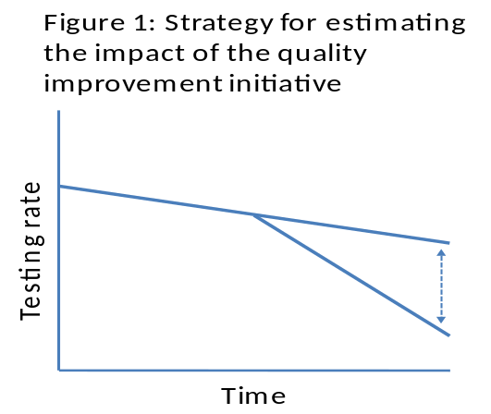

Figure 2: Strategy for Evaluating the Impact of the Quality Improvement Initiative

We will compare trends in the endpoints prior to and during the intervention. We expect that for each outcome and condition, the intervention will change the slope of the trend line. Figure 2 illustrates this approach. The effect of the intervention is measured by the vertical distance between the pre-existing trend line and the post-intervention trend line. Our primary endpoints are measures of resource use (e.g. testing rates, hospital admission rates). Length of stay and return rates are secondary endpoints.

We will implement the evaluation strategy by estimating logistic regression models of the following form:

 [equation1]

Where i indexes patients, j indexes physicians, and t indexes time,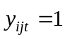 if the patient received a test and otherwise, is a latent variable such that , t is a time trend indicator, P is an indicator variable for whether or not the patient received treatment after the quality improvement intervention was initiated,  is a physician-specific random effect to account for clustering at the physician level, and  is an identically and independently distributed error term. The coefficient on the interaction of time with the intervention indicator, , is of primary interest. Patient-level covariates will be included in each regression as appropriate. Results will be stated in terms of marginal effects (e.g. the change in the probability that a patient receives a test pre- and post-intervention), with confidence intervals calculated via the delta method.

We will perform a falsification test by re-estimating the model on a sample of patients with conditions other than the four included conditions noted above. Patients with these other conditions, which are not included in the feedback reports, form a kind of quasi-control group.

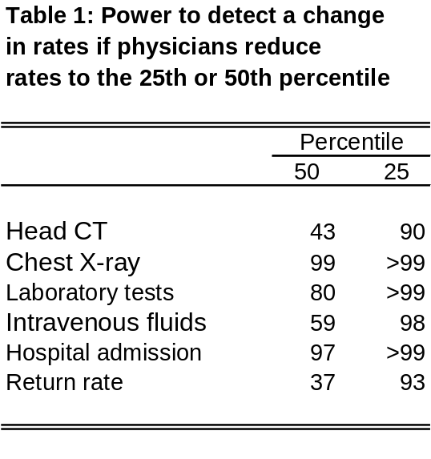
In addition to reducing resource use rates, length of stay, and return rates, we also hypothesize that the intervention will reduce physician-level variation in each of the endpoints. We can test the hypothesis using the following procedure: (1) estimate multilevel models for each endpoint, similar to equation [1] above, with a single physician-level variance component, (2) re-estimate the models with an additional error component that permits the physician-level variance component to differ between the pre- and intervention phase, and (3) use likelihood-ratio tests to compare the models with and without the additional error component.

We calculated statistical power based on our ability to detect differences in rates between the pre-intervention period and the intervention period. To simplify the analysis, we assumed that there are no underlying, secular trends in endpoints.

Based on preliminary data, we assumed that there are 80 physicians, each of whom treats 150 patients in each period (pre- and intervention-) for each of the four conditions. We used Monte Carlo simulation to estimate power while accounting for physician-level clustering. The analysis proceeds in the following steps: 1) We constructed vectors of normally-distributed random draws for each physician. Each draw represents a patient. The random draws consist of an independently distributed component and a common term. The common term captures each physician’s “practice style” and induces a within-physician correlation among the simulated patients treated by the same physician. We set the ratio of the independent and common term so that, for each test, the simulated variation in physician level testing rates equals the observed variation. 2) We calculated reasonable effect sizes using the following procedure. For each test measure, we calculated how the average testing rate would change if, following the intervention, physicians with testing rates above the median reduce their testing rates to exactly the median. The difference between the actual mean and the post-intervention mean is the hypothesized effect size. We also calculated an effect size assuming that physicians with testing rates above the 25th percentile reduce their rates to the 25th percentile. 3) We transformed the normally-distributed random variables calculated in step 1 into a dichotomous measure (test/no test) based on current testing rates and the hypothesized effect sizes from step 2. 4) We estimated a logit model, with random effects to account for clustering at the physician level, using the simulated data and recorded whether a dichotomous treatment variable was significantly different from zero. 5) We performed 1,000 replications of steps 1-4.

The results are displayed in Table 1. In general, for most measures we will have good power (> 80) to detect reasonable effect sizes.

Data Collection and Handling:

Data procurement: Both EDs have electronic medical records with electronic signature capture that allows for accurate physician attribution; computerized physician order entry will ensure that resource use is accurately assigned to the ordering physician. Data gathered from the electronic medical record is housed in a database. Physician practice data will be obtained from this existing hospital database which now has nearly 1 million patient visits attended by over 80 attending level ED providers. Data will be aggregated at the level of the provider - no identifying patient information is needed for the project, and none will be recorded. Physicians will be identified by blinded codes that will not be accessible to investigators.

Data management and storage: Blinded data collected as above will be stored in a password protected database on Children’s Healthcare of Atlanta computers, and will be available only to study investigators.

Data Analysis: Again, no physician- or patient- identifying information will be used for data analysis; blinded, aggregate data will be used for data analysis by statisticians.

Potential Use of Study Findings:

1. Our effort to develop a composite measure that encompasses both quality and resource use will address the growing need for comprehensive healthcare performance measures.
2. Such a measure could also potentially meet the Joint Commission’s Ongoing Professional Performance Evaluation (OPPE) requirement for hospitals to manage performance of their medical staff in different specialties.³²
3. We anticipate reduction in resource overuse while maintaining/improving outcomes and thus optimizing value of ED care. Because this model is episode-based, severity-adjusted, and measures “value” at the individual provider level, our methodology can potentially facilitate creation of unbiased measures for public reporting of ED provider performance. Additionally, such information is a prerequisite for moving towards value-based payment efforts. Given recent healthcare reform discussions on Accountable Care Organizations and bundled payments for hospitals and physicians, an initiative to identify high-value providers could be a win-win situation for both parties.

References:

APPENDIX: Sample Physician Scorecard showing Resource Use Rates, Length of Stay and Return Rates for four conditions: Acute Gastroenteritis, Head Injury, Respiratory Illness and Fever 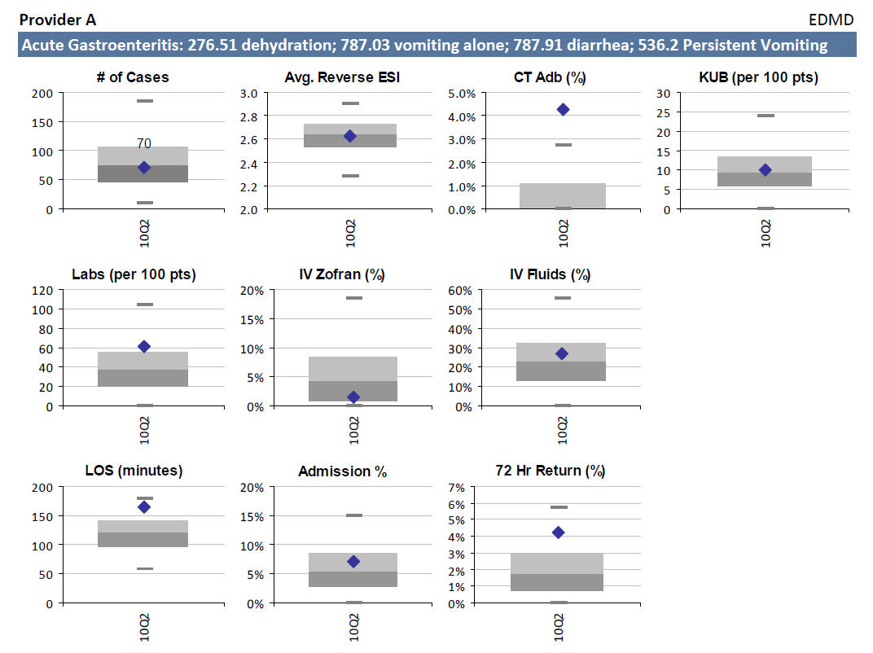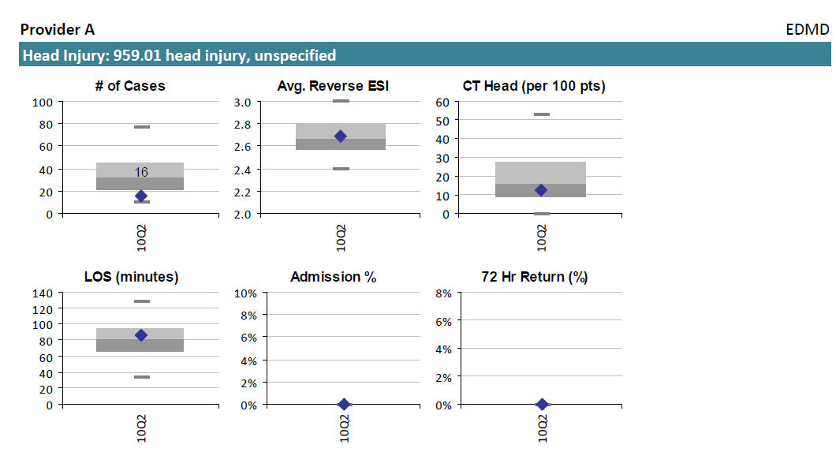

Sample Report Card – continued:
